**Cup van de Burgemeester**

**5 and 6th AUGUST 2023**

**SAILING INSTRUCTIONS**

**1.GOVERNING RULES**

The Championship will be governed by:

- 1.1 The world sailing Rules 2021 - 2024

- 1.2 The prescriptions of de KBYV- FRBY.

- 1.3 Boats may be required to present a valid publicity certificate delivered by their National Authorities.

**2. NOTICES TO THE COMPETITORS**

- Notices to competitors, including any changes to the schedule of races or the Sailing Instructions shall be posted on the official notice board at the regatta office.

**3. CHANGES TO SAILING INSTRUCTIONS**

- Any change to the Sailing Instructions will be posted at least 15 minutes before flag “AP” is hosted, except that any change to the schedule of races will be posted by 20:00 on the day before it will take effect.

**4. SIGNALS MADE ASHORE**

- 4.1 Signals made ashore will be displayed from a flag staff located near the clubhouse.

- 4.2 When flag "AP" is displayed ashore, "1 minute" is replaced with "not less than 30 minutes" in race signal "AP". Boats are requested not to leave the beach until this signal is removed.

**5. SCHEDULE OF RACES AND FORMAT**

- 5.1 The time schedule for the Challenge is as follows:

|  |  |  |
| --- | --- | --- |
| **Schedule** | | |
| **Date** | **Time** | **Event** |
| 5 August Saturday | 09:30  11:30  12:55  19:00 | Registration + boot preparation  Briefing  Warning Signal 1st race of the day. The warning signal for each succeeding race will be made as soon as practicable.  Diner, if races are finished. |
| 6 August Sunday | 09:00  10:00  10:55  17:00 | Boot preparation  Briefing  Warning Signal Raid.  Price giving. |

5.2 8 races are scheduled with a maximum of 4 sailed races a day, except when races have been postponed on the previous day.

- 5.3 3 sailed races must be completed to validate the Challenge.

- 5.4 When more than one race will be held on the same day, the warning signal for each succeeding race will be made as soon as practicable.

**6. CLASSE FLAGS**

- 6.1 Class flag for the C1 fleet will be a white "F18" flag.

- 6.2 Class flag for the C3 and dinghy fleets will be a “KYC” flag.

**7. RACING AREA**

- 7.1 The Racing Area is the North Sea; starting line in front of the KYC if possible.

- 7.2 The Regatta site is the Dumontlaan 8, 7680 Koksijde

- 7.3 Raid will be between KYC and ODK

**8. THE COURSES**

- 8.1 The Championship will use windward / leeward courses with a gate.

- 8.2 Diagrams in attachment 1 show the courses. Boats shall sail between the gate marks from de direction of the previous mark and round either gate mark.

- long distance diagram will be on the notice board on sunday morning briefing

- 8.3 When a gate mark is not in place, the remaining mark will be rounded to PORT

**9. MARKS**

- 9.1 All marks will be large inflatable yellow buoys, some with "SHIP SHOP Label"

- 9.2 The starting line will be between a staff on the RC Signal boat which is displaying an "ORANGE" flag at the starboard end and the port end starting mark (RED buoy).

- 9.3 The finishing line will be between a staff on the RC Signal boat which is displaying a "BLUE" flag at the starboard end and the port end finishing mark (RED buoy).

**10. THE START**

- 10.1 The RC Signal boats may use their engines to stay in position if needed; this cannot be used as ground for protest or redress by a boat.

**11. CHANGE OF THE POSITION OF THE NEXT MARK**

- 11.1 To change the position of the next mark, the race committee will move the original mark (or the finishing line) to a new position. The change will be signalled before the leading boat has begun the leg, although the mark may not yet be in the new position. Any mark to be rounded after rounding the moved mark may be relocated without further signalling, to maintain the course configuration.

**12. PENALTY SYSTEM**

- 12.1 The alternative penalty rules RRS 44.1 and 44.2 are changed so that the two-turn shall be replaced by a one-turn and shall include one tack and one gybe.

- 12.2 A boat that has taken a penalty under RRS 44.1 or retired under RRS 31.2 shall complete and file an acknowledgement form at the Regatta Office.

- 12.3 As provide in RRS 67, the jury may, without a hearing, penalize a boat that has broken RRS 42.

**13. TIME LIMITS**

- 13.1 Boats failing to finish within 20 minutes in real time after the fist boat of their class who sails the course properly and finishes will scored Did Not Finish.

- 13.2 A race shall be abandoned if no boat finishes within 90 minutes. This time limit is not applicable for raids or long distance races.

- 13.3 A boat starting later than 5 minutes after her starting signal will be scored "DNS".

**14. PROTEST AND REQUEST FOR REDRESS**

- There will be no protest committee, as we expect ALL competitors to sail a FAIRPLAY regatta .

- Might there be a discussion, this could be judged by the Race Officer.

If no solution to the problem, we still can have a decision of a Protest Committee later on.

**15. SCORING**

- 15.1 The RRS Appendix A4.1 - Low Point Scoring system will be used. Elapsed times will be corrected according to the most recently published SCHRS list.

- 15.2 When 4 or more races have been completed, the worst score will be excluded.

- 15.3 When 8 or more races have been completed, the two worst scores will be excluded.

- 15.4 Three races are required to validate de Challenge.

- Raid will score double points

**17. SAFETY REGULATIONS**

- 17.1 RRS 40 applies at all times while afloat, although flag "Y" will not be displayed. This changes RRS 40.

- 17.2 Complementary to the Class Rules – Safety Equipment - all boats must be equipped with,

one flare and a personal floating device on each crew member*.*

A towing rope of 15 meters long and 6 mm in diameter

A righting rope of 4 meters long and 10 mm in diameter

A wetsuit or drysuit is obligatory at all times while afloat

Note: lengths and diameters specified in this article have to be read as minimum.

- 17.3 A boat that retires from a race shall notify the race committee as soon as possible.

**18. REPLACEMENT OF CREW OR EQUIPMENT**

- 18.1 Substitution of damaged or lost equipment will not be allowed unless approved by the race committee. Requests for substitution shall be made to the committee at the first reasonable opportunity.

- 18. Substitution of competitors will not be allowed without approval of the Race Committee

**19. SUPPORT BOATS**

- 20.1 Team leaders, coaches and other support personnel shall remain at least 100 metres outside areas where boats are racing from the time of the preparatory signal for the first fleet to start until all boats have finished or the race committee signals a postponement, general recall or abandonment.

- 20.2 The penalty for infringing these requirements will be at the discretion of the jury, but may include disqualification of one or all boats associated with the infringing vessel.

**20. RADIO COMMUNICATION**

- A boat shall neither make radio transmissions while afloat nor receive radio communications not available to all boats. This restriction also applies to mobile telephones except when required by the organising authority for long distance races.

**21. PRIZES**

- 22.1 Main prices will be awarded to helmsman and crew of the winning boats.

- 22.2 Several prizes will be awarded at the discretion of the race organisation.

- 22.4 PRIZES WILL BE REWARDED ONLY TO TEAMS WHO ATTEND THE PRIZE GIVING (REPRESENTED BY THEMSELVES)

**22. DISCLAIMER OF LIABILITY**

- 23.1 Competitors participate in the regatta entirely at their own risk. Attention is drawn to the Fundamental RRS 4, Decision to race. The Organising Authority and the sponsors and their officers, jointly and severally, will not accept any liability for personal or material damage, injury or death sustained in conjunction with or prior to, during or after the regatta.

- 23.2 Any competitor under the age of 18 yrs will be required to obtain parental/guardian consent prior to commencement of Championship.

**23. INSURANCE**

- Each participant shall have a current Public Liability and Third Party Property Insurance policy, including coverage when racing at the venue of the Championship, of not less than 2.500.000 € or equivalent for each boat.

**24. ELIGIBILITY**

* 1. - All entrants, to be eligible for the Championship, shall: o Comply with RRS Appendix 2 – World Sailing Eligibility Code.
  2. o Be current financial members of their National Multihull Association.
  3. o Have a current Public Liability and Third Party Property Insurance policy, including coverage when racing at the venue of the Championship, of not less than 2.500.000 € or equivalent for each boat.
  4. o Any competitor under the age of 18 yrs will be required to obtain parental/guardian consent prior to commencement of Championship.

**25. IMAGE AND MEDIA RIGHTS**

- In sailing the Challenge a competitor automatically grants to the Organising Authority and the sponsors of the event the right in perpetuity to make, use and show from time to time and at their discretion, any motion or still pictures, and live, taped or film television and any other reproductions of him/her during the period of the Challenge in which the competitor competes and in all material related to the Championship without any compensation.

**Officials:** Race Committee

Race Officer: Boudewijn Tanghe 0472 41 70 68

Rescue : Nore Daelemans 0474688913

**Saturday Races**

STARTING LINE IS DEFINED BY **RED** BUOY ON PORT AND MOTORVESSEL ‘ *To be comfirmed’* ON STARBOARD

FINISHING LINE IS DEFINED BY **RED** BUOY ON PORT AND MOTORVESSEL ‘ *To be comfirmed’*’ ON STARBOARD

MARKS 1, 2 AND GATE : **YELLOW** BUOYS

CLASS FLAG C1 : **F18** (WHITE-PINK)

CLASS FLAG C3 + DINGHIES + C4 **: KYC (blue)**

**COURSE C1 : START -1-2-gate -1-2-gate -1-2-gate-finish**

**COURSE C3 : START -1-2-gate-1-2-gate-finish**

**(COURSE C4 : START -1-2-gate-finish)**

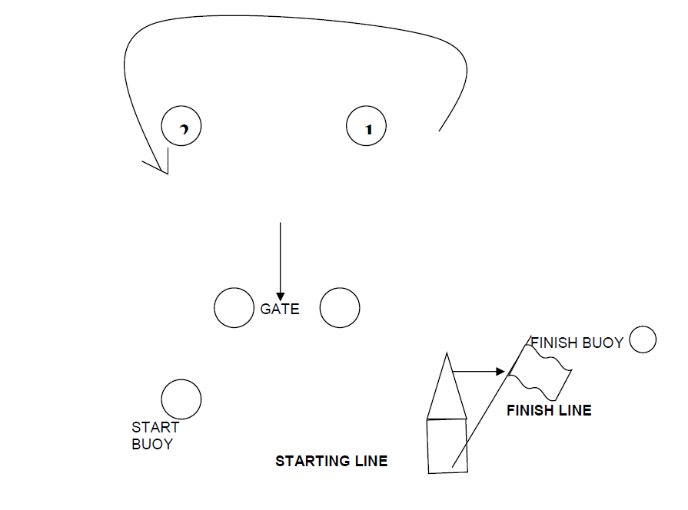

**Sunday Raid:** diagram will be posted no later than 10:00pm at the regatta office.